**Creating Microservices for account and loan**

**ACCOUNT :**

**AccountApplication.java**

package com.cognizant.account;  
  
import org.springframework.boot.SpringApplication;  
import org.springframework.boot.autoconfigure.SpringBootApplication;  
  
@SpringBootApplication  
public class AccountApplication {  
  
 public static void main(String[] args) {  
 SpringApplication.*run*(AccountApplication.class, args);  
 }  
  
}

**AccountController.java**

package com.cognizant.account.controller;  
import org.springframework.web.bind.annotation.GetMapping;  
import org.springframework.web.bind.annotation.PathVariable;  
import org.springframework.web.bind.annotation.RestController;  
  
import java.util.Map;  
  
@RestController  
public class AccountController {  
 @GetMapping("/accounts/{number}")  
 public Map<String, Object> getAccountDetails(@PathVariable String number) {  
 return Map.*of*(  
 "number", number,  
 "type", "savings",  
 "balance", 234343  
 );  
 }  
}

**Pom.XML**

*<?*xml version="1.0" encoding="UTF-8"*?>*<project xmlns="http://maven.apache.org/POM/4.0.0" xmlns:xsi="http://www.w3.org/2001/XMLSchema-instance"  
 xsi:schemaLocation="http://maven.apache.org/POM/4.0.0 https://maven.apache.org/xsd/maven-4.0.0.xsd">  
 <modelVersion>4.0.0</modelVersion>  
 <parent>  
 <groupId>org.springframework.boot</groupId>  
 <artifactId>spring-boot-starter-parent</artifactId>  
 <version>3.5.3</version>  
 <relativePath/> *<!-- lookup parent from repository -->* </parent>  
 <groupId>com.cognizant</groupId>  
 <artifactId>account</artifactId>  
 <version>0.0.1-SNAPSHOT</version>  
 <name>account</name>  
 <description>Demo project for Spring Boot</description>  
 <url/>  
 <licenses>  
 <license/>  
 </licenses>  
 <developers>  
 <developer/>  
 </developers>  
 <scm>  
 <connection/>  
 <developerConnection/>  
 <tag/>  
 <url/>  
 </scm>  
 <properties>  
 <java.version>21</java.version>  
 </properties>  
 <dependencies>  
 <dependency>  
 <groupId>org.springframework.boot</groupId>  
 <artifactId>spring-boot-starter-web</artifactId>  
 </dependency>  
  
 <dependency>  
 <groupId>org.springframework.boot</groupId>  
 <artifactId>spring-boot-devtools</artifactId>  
 <scope>runtime</scope>  
 <optional>true</optional>  
 </dependency>  
 <dependency>  
 <groupId>org.springframework.boot</groupId>  
 <artifactId>spring-boot-starter-test</artifactId>  
 <scope>test</scope>  
 </dependency>  
 </dependencies>  
  
 <build>  
 <plugins>  
 <plugin>  
 <groupId>org.springframework.boot</groupId>  
 <artifactId>spring-boot-maven-plugin</artifactId>  
 </plugin>  
 </plugins>  
 </build>  
  
</project>

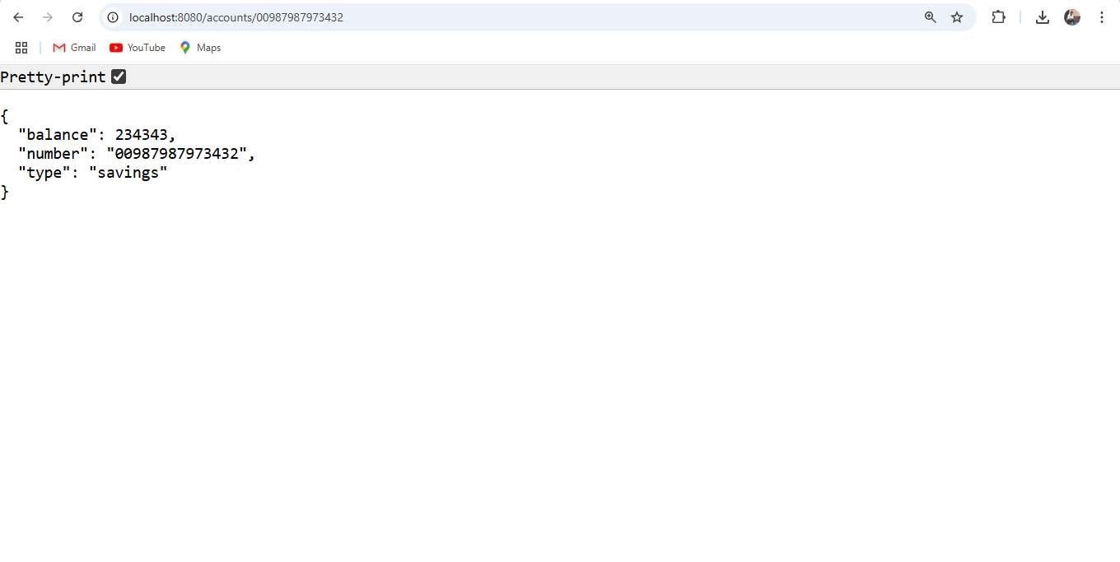**LOAN:**

**LoanApplication.java**

package com.cognizant.loan;  
  
import org.springframework.boot.SpringApplication;  
import org.springframework.boot.autoconfigure.SpringBootApplication;  
  
@SpringBootApplication  
public class LoanApplication {  
  
 public static void main(String[] args) {  
 SpringApplication.*run*(LoanApplication.class, args);  
 }  
  
}

**LoanController.java**

package com.cognizant.loan.controller;  
import org.springframework.web.bind.annotation.GetMapping;  
import org.springframework.web.bind.annotation.PathVariable;  
import org.springframework.web.bind.annotation.RestController;  
  
import java.util.Map;  
  
@RestController  
public class LoanController {  
  
 @GetMapping("/loans/{number}")  
 public Map<String, Object> getLoanDetails(@PathVariable String number) {  
 return Map.*of*(  
 "number", number,  
 "type", "car",  
 "loan", 400000,  
 "emi", 3258,  
 "tenure", 18  
 );  
 }  
}

**ApplicationProperties**

spring.application.name=loan  
server.port=8081

**Pom.XML**

*<?*xml version="1.0" encoding="UTF-8"*?>*<project xmlns="http://maven.apache.org/POM/4.0.0" xmlns:xsi="http://www.w3.org/2001/XMLSchema-instance"  
 xsi:schemaLocation="http://maven.apache.org/POM/4.0.0 https://maven.apache.org/xsd/maven-4.0.0.xsd">  
 <modelVersion>4.0.0</modelVersion>  
 <parent>  
 <groupId>org.springframework.boot</groupId>  
 <artifactId>spring-boot-starter-parent</artifactId>  
 <version>3.5.3</version>  
 <relativePath/> *<!-- lookup parent from repository -->* </parent>  
 <groupId>com.cognizant</groupId>  
 <artifactId>loan</artifactId>  
 <version>0.0.1-SNAPSHOT</version>  
 <name>loan</name>  
 <description>Demo project for Spring Boot</description>  
 <url/>  
 <licenses>  
 <license/>  
 </licenses>  
 <developers>  
 <developer/>  
 </developers>  
 <scm>  
 <connection/>  
 <developerConnection/>  
 <tag/>  
 <url/>  
 </scm>  
 <properties>  
 <java.version>21</java.version>  
 </properties>  
 <dependencies>  
 <dependency>  
 <groupId>org.springframework.boot</groupId>  
 <artifactId>spring-boot-starter-web</artifactId>  
 </dependency>  
  
 <dependency>  
 <groupId>org.springframework.boot</groupId>  
 <artifactId>spring-boot-devtools</artifactId>  
 <scope>runtime</scope>  
 <optional>true</optional>  
 </dependency>  
 <dependency>  
 <groupId>org.springframework.boot</groupId>  
 <artifactId>spring-boot-starter-test</artifactId>  
 <scope>test</scope>  
 </dependency>  
 </dependencies>  
  
 <build>  
 <plugins>  
 <plugin>  
 <groupId>org.springframework.boot</groupId>  
 <artifactId>spring-boot-maven-plugin</artifactId>  
 </plugin>  
 </plugins>  
 </build>  
  
</project>

